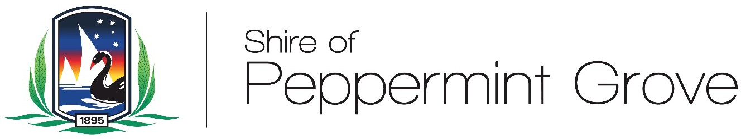

Reconciliation Action Plan Community group (RAPCRG)

Frequently Asked Questions

What is Reconciliation?
In the context of Reconciliation Action Plans, reconciliation means “growing Positive, two-way relationships built on trust and respect between Aboriginal and Torres Strait Islander and non-Indigenous Australians throughout society.”
Creating a society that values and recognises Aboriginal and Torres Strait Islander cultures and heritage as a proud part of as a shared national identify. The active support of reconciliation by the nation’s political, business and community structures.” (Reconciliation Australia, 2018).
What is a Reconciliation Action Plan (RAP)?
A Reconciliation Action Plan (RAP) is a document that outlines how an organisation will realise their vision for reconciliation by creating practical actions built on relationships, respect and opportunity. It is reported that there are over 650 registered RAPS in Australia and over 500 currently in development.
What is a Reflect RAP?
Reconciliation Australia’s RAP program has four consecutive levels (RISE) that progress through Reflect, Innovate, Stretch and Elevate. The Shire will commence in Stage one by developing a Reflect Level RAP: This has a focus on building respectful relationships with Aboriginal and Torres Strait Islander people as a strong foundation for future reconciliation efforts.
Why is the Shire of Peppermint Grove developing a RAP?
The intention of the RAP is to strengthen the Shires reconciliation commitments by encouraging relationships between Aboriginal and Torres Strait Islander peoples, communities, organisation’s and the broader community. A RAP would help to embed respect, participation and opportunity to improve cultural and socio-economic outcomes for Aboriginal and Torres Strait Islander people and the whole community.

What is the purpose of the RAPCRG?
The purpose of the RAPCRG group is to meet, discuss and draft the development of Shire of Peppermint Grove’s RAP.
Why is a community reference group needed?
The RAPCRG will help guide the vison, strategies and actions contained within the RAP. The RAPCRC is important to contribute ideas, provide advice, share information and help oversee the development of the RAP. It will ensure the RAP is guided by Aboriginal and Torres Strait Islander knowledge and perspectives.
Can the RAPCRG make decisions at its meetings?
The RAPCRG can discuss matters, exchange views and collectively guide the process or make recommendations. The RAPCRG cannot make decision that commit the Shire to spend money.
Who makes the final decision to approve the RAP?
The Shire will submit the draft RAP to Reconciliation Australia for their review and endorsement. Following that, Council will ultimately make the decision to approve the Shire of Peppermint Reconciliation Action Plan.
Who is Reconciliation Australia?
Reconciliation Australia is the peak body for reconciliation in Australia. They are an independent, not for profit organisation that promotes and facilitates reconciliation by providing an oversight role through advocacy, creating awareness and supporting organisations with information and templates to develop, maintain and implement meaningful RAPS. The purpose of Reconciliation Australia is to “inspire and enable all Australians to contribute to the reconciliation of the nations.”
How is the Shire communicating the Expression of Interest process to its residents?
Public advertising of the EOI process will be by way of advertising in the community newspapers, information on the Shire’s website, and by invitation to individuals who have previously contacted the Shire directly with an interest in development of a RAP.
I am an individual that wants to nominate for the group – how do I do this?
Read the Terms of Reference for the RAPCRG and if you have any questions, contact the Shire on the telephone number/email address provided below. Once you are satisfied that you can meet the criteria, complete and submit the Nomination Form before the closing date.

I want to nominate myself to represent the interest group I am a member of - how do I do this?
It is the same process as detailed above with the added obligation of getting approval from the group you are a member of. The group will need to approve your nomination and please state this is the case on your Nomination Form.
What would be expected of me as a member of the RAPCRG?
If you have agreed to the Terms of Reference for the RAPCRG by checking the box, this document details the criteria on being a member. In summary, it is to attend scheduled meetings and engage in positive and respectful discussion on agenda items. Providing feedback to and from the community is also requested on the group members.
How often and what time will the meetings be?
The meetings will be approximately every two or three months. The meetings will be during the working week, outside of normal business hours. Meeting times are yet to be decided but as a guide – 5.30pm and for up to 1.5 hours.
What is I become a member of the RAPCRG but cannot attend a scheduled meeting?
If you cannot attend a meeting for some reason, please let the Shire know as soon as possible. It is requested that every effort is made by the RAPCRG members to attend all scheduled meetings.
Where will the meetings be held?
The venue for meetings will be in the Council Chambers at the Shire of Peppermint Grove, 1 Leake Street Peppermint Grove. Prior notice of the meeting room, will be given on the agenda.
Will I get paid?
Membership of the Reference Group is voluntary. There is no payment or reimbursement for out-of-pocket expenses.
How long do we have to send in our Nomination Forms?
Expression of Interest will be over a 30 day advertising period, closing 5.00pm 30th June 2023.
What happens once the EOI process has closed?
Once the period for the receipt of completed nominations has closed, the details on the Nomination Forms will be assess against the requirement of the RAPCRG Terms of Reference to have diverse community representation. A report with recommendations will be submitted to Council seeking endorsement of the RAPCRG members.
Successful nominees will be advised by the Shire within three weeks from Council’s approved selection.
What is my nomination is unsuccessful?
The Shire will advise you if your nomination is unsuccessful. There will be other opportunities for you to contribute to the RAP as part of a full community consultation taking place in the future.
Who do I contact for more information?
For further information, please contact administration on 9268 8600 or email admin@peppermintgrove.wa.gov.au.

