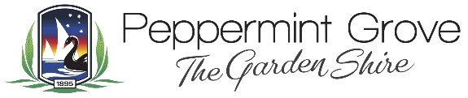
Shire of Peppermint Grove
For the financial year ending 30 June 2023
Pursuant to section 5.127 of the Local Government Act 1995:
- A local government must prepare a report for each financial year on the training completed by council members in the financial year.
- The CEO must publish the report on the local government website within 1 month after the end of the financial year to which the report relates.
Council Members | Training Course | Completion Date
Cr Doug Jackson | Understanding Local Government | 1 September 2022
 | Conflicts of Interest | 1 September 2022

